Khan's log
Star date 11/17/14
We have spent the last few days in a hasty attempt to attach the Da Vinci tube to the drawer slides and we have encountered a problem. We have discovered that since the Da Vinci tube was designed to output the balls out its top end and down a small funnel, it was in need of a conveyor system to move the balls up its length against gravity. Since none of our attempts at a compact conveyor belt have succeeded, we are forced to come up with a different solution. We have thus decided to make the whole tube rotate upwards and let gravity work for us to take the balls to the back end of the tube. This however requires a massive hinge mechanism that adds a lot of weight to the top of the robot.
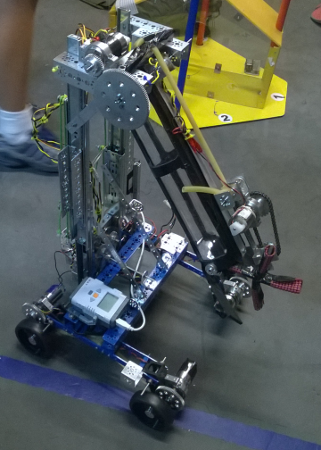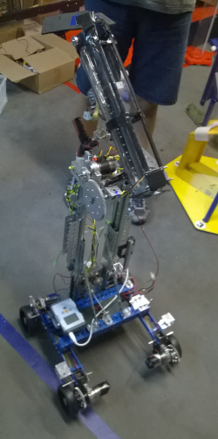
We have also encountered problems with the Da Vinci tube's intake system. Since the tube is a 3" diameter tube and the larger sized balls are 3" in diameter, it makes it difficult for the balls to get into the tube with just a simple brush. To fix this problem we have made some guides out of craft foam that act like a funnel to guide the balls into the tube.
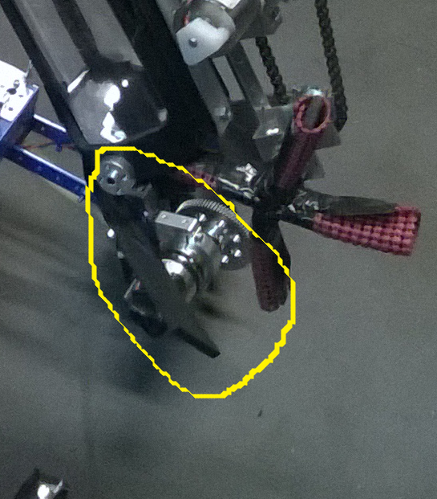

Khan's log
Star date 11/23/14
Upon further testing, the weight of the hinge system that rotates the tube has proven too great for both the chassis and the winch motor that drives the drawer slides. In response to this problem, our team have put our heads together to create a compact conveyor belt that will actually work. We first looked to solve the problem of the conveyor belt slipping on its sprockets. To do this we selected a chain as the best candidate because chains do not easily slip. Second, we addressed the problem of mounting encourager paddles to a chain. In past experience, we have seen that we cannot attach things directly to a chain because the sprocket will simply bite them off. One idea we had was to somehow extend the pins that hold each chain link together and then simply attach our paddles outside the chain. We then experimented with several methods of extending the pins and have settled using nails. The nails that we have chosen fit the chain almost perfectly and give us mounting points on the outside of the chain to attach our paddles.
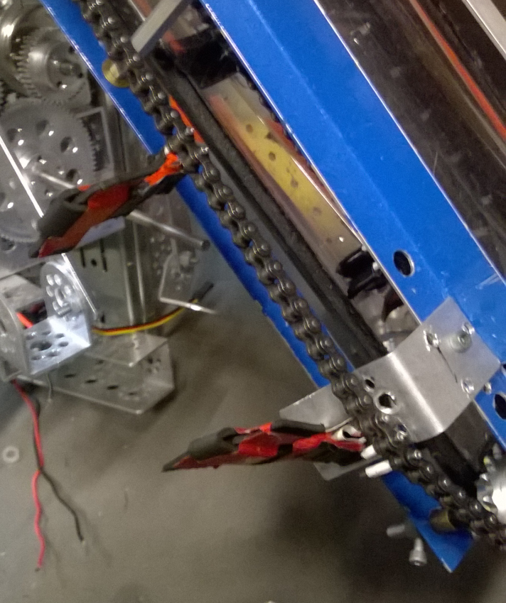
The new chain belt now alows us to remove the complex hinge that has been hindering our progres thus far and it also meens that we can use the Da Vinci tube the way it was origanaly intended.
Another problem we have encountered that is that since the nacelles are 3D printed with ABS plastic, they have a slight problem with bending just enough to let the gears slip. This problem has an amplified effect whene the robot has the weight of a riser system and intake tube. Due to the slipping problem, the robot struggles to turn and drives poorly. To fix this problem, we have designed sheet metal "shin guards" to reinforce the nacelles.

